

**Εθνικό και Καποδιστριακό Πανεπιστήμιο Αθηνών**

**Τμήμα Πληροφορικής και Τηλεπικοινωνιών**

Μάθημα: «Τηλεπικοινωνιακά Υποσυστήματα»

Project

*Γεωργάρα Βασιλική*

*1ο Εξάμηνο*

*en2190002*

**Διδάσκοντες:**

Νίκας Θωμάς

Καραμπέτσος Σωτήριος

3 Φεβρουαρίου 2020

Αθήνα

**BPSK: Binary Phase Shift Keying**

**Baseband, with no Pulse Shaping**

***Binary Phase Shift Keying (BPSK)*** is a two-phase modulation scheme, where the 0’s and 1’s in a binary message are represented by two different phase states in the carrier signal: \theta=0^{\circ} for binary 1 and \theta=180^{\circ} for binary 0, - the main advantage of which is the high level of resistance against errors in the

transmission of the signal through the communication channel.

The Constellation Diagram for BPSK:

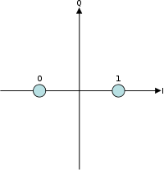

# **Example of BPSK modulation format, (a) binary signal, and (b) BPSK modulated signal**

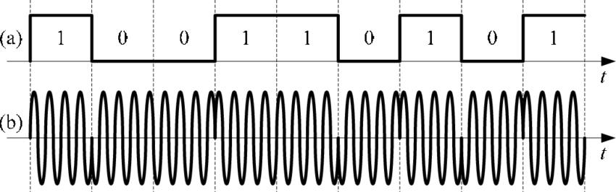

**BIT ERROR RATE (BER):**

The [bit error rate](https://en.wikipedia.org/wiki/Bit_error_rate) (BER) of BPSK under [additive white Gaussian noise](https://en.wikipedia.org/wiki/Additive_white_Gaussian_noise) (AWGN) can be calculated as:

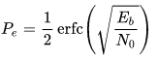

**or**

Since there is only one bit per symbol, this is also the symbol error rate.

**Benefits or advantages of BPSK**

➨It is most robust modulation technique due to the fact that binary 1 and 0 are separated by 180 degree phase shift of the carrier. Due to this property, BPSK modulated data can travel longer distances when transmitted from base station or subscriber stations. Hence BPSK modulation is employed in pilot carrier as well as in preamble sequences. These are used for time/frequency synchronization and channel estimation/equalization purpose.  
➨Due to above, BPSK modulation is used by most of the cellular towers for long distance communication or transmission of the data.  
➨BPSK demodulator requires to make only two decisions in order to recover original binary information. Hence BPSK receiver is very simple compare to other modulation types.  
➨BPSK is power efficient modulation technique as less power is needed to transmit the carrier with less number of bits.

**Drawbacks or disadvantages of BPSK**  
➨In BPSK modulation, one bit is carried by one single analog carrier. Hence data rate in bits per second is same as the symbol rate. This is half in comparison to the QPSK modulation technique and many times less compare to other higher modulation techniques such as 16QAM, 64QAM etc.  
➨Due to above reason, BPSK is not bandwidth efficient modulation technique compare to other modulation types.

The BER for M-ary BPSK for different values of Eb/No of the AWGN channel is shown in Table 3 below.

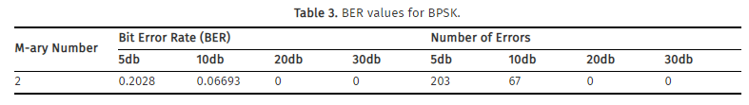

For the implementation of a SIMULINK BPSK model in AWGN with no carrier, I have the following specifications:

1. Bit rate Rb = 2Mbps

2. BPSK Modulation

3. Additive White Gaussian Noise Channel AWGN

4. BPSK Demodulation

5. Measurement of BER vs. Eb/No

6. Compare with theoretical BER vs. Eb/No

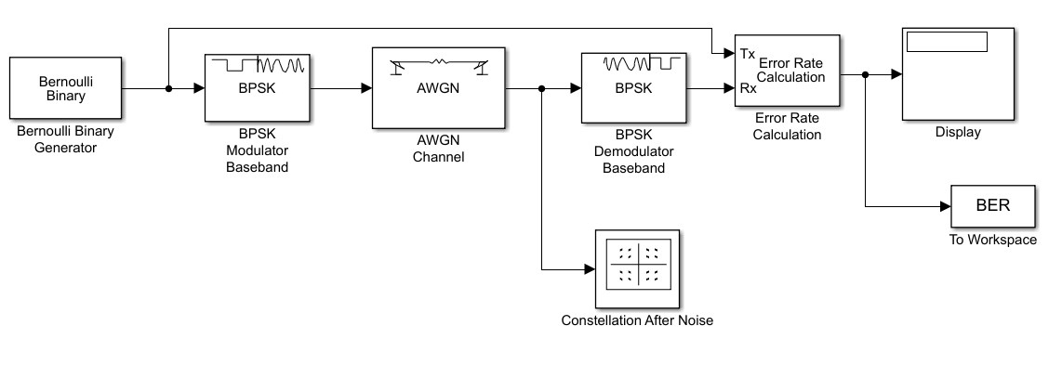Starting with Simulink, I have the following image:

**And I will set the parameters regarding Rb.**

|  |
| --- |
| Rb = 2 Mbps = 2*106 bits/sec |

M = number of symbols = 2κ, where k = number of bits. -> **k=1, M=2**

In BPSK, the possible bits that I can have are 2, bit 0 and bit 1, so Μ = 2.

|  |
| --- |
| **Tb = 5e-7** |

Tb = (1/Rb)*log2(M) = (1/(2*106)) * log2(2) = 0.5*10-6 sec = 5e-7 =>

**So, for every block, I have the following parameters:**

* Bernoulli Binary Generator:

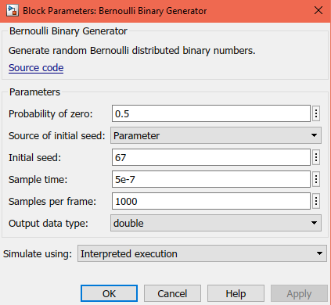Set:

Initial Seed:**67**

Sample time:**5e-7**(=Tsym)

Samples per frame:**1000**

Output data type: **double**

* BPSK Modulator και Demodulator:

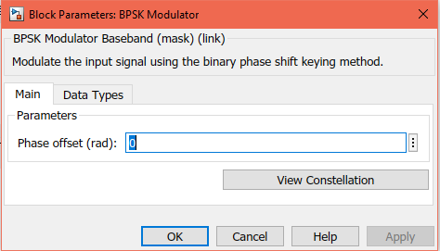

**No change. All by default.**

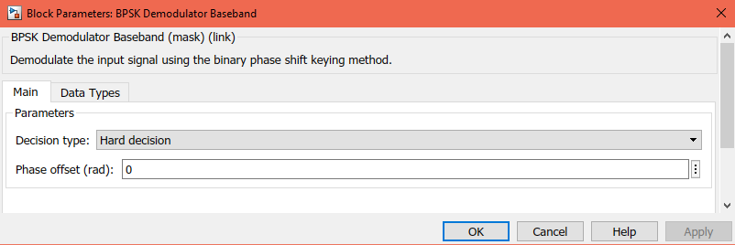

* AWGN:

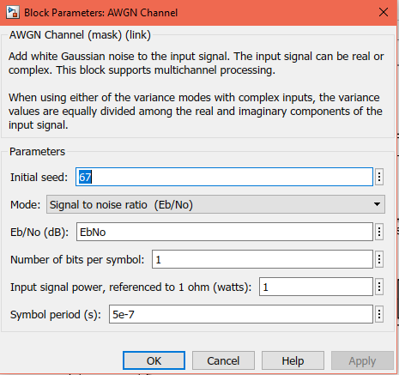

Eb/No(dB): **EbNo**

Number of bits per symbol: **1** (=log2(M)=log2(2)

Symbol period: **5e-7** (=Tsym)

* Error Rate Calculation:

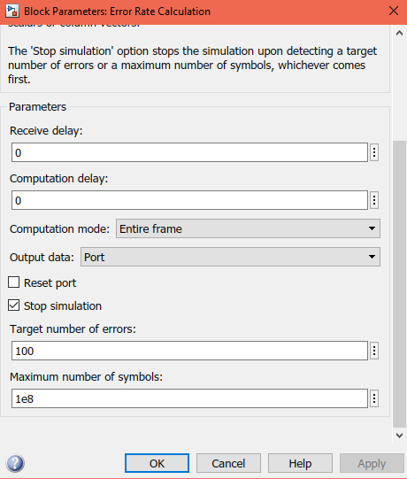

Output data: **Port** so that it can connect with block Display

Check Stop Simulation with parameters

Target number of errors: **100**

Maximum number of symbols: **1e8**

* 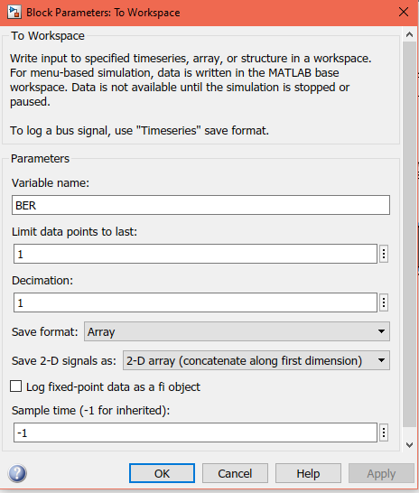workspace:

Set:

Variable name: **BER**

Limit data points to last: **1**

Save Format: **Array**

As: **2-D array**

Uncheck log fixed-point data as a fi object

* Display:

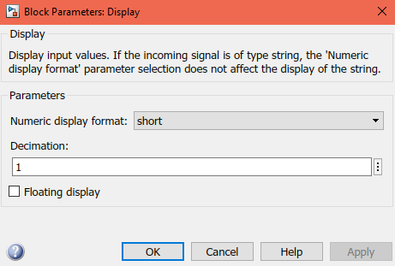

**No change. All by default.**

Afterwards, in Matlab we type:

 To initialize the variable of EbNo and gradially increase it.

Bertool is the command to open the BER analysis tool.

The following window opens. In the tab Theoretical press Plot, to plot the theoretical curve of BER in BPSK.

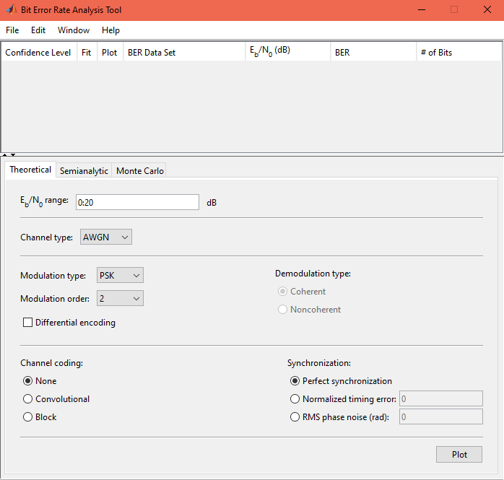

Set correctly the corresponding values to our Simulation type..

Set range of EbNo starting from 0 to 20.

Then Plot.

The theoretical BER is shown below.

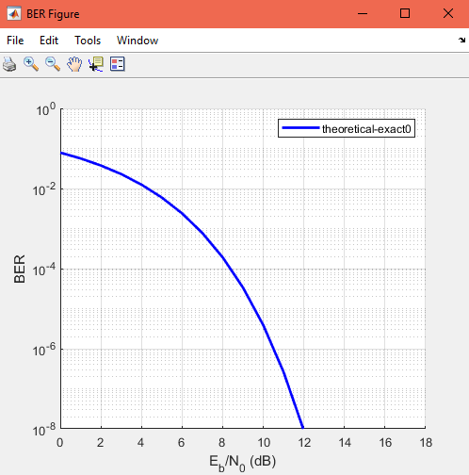

For BPSK in AWGN channel, the BER is

.

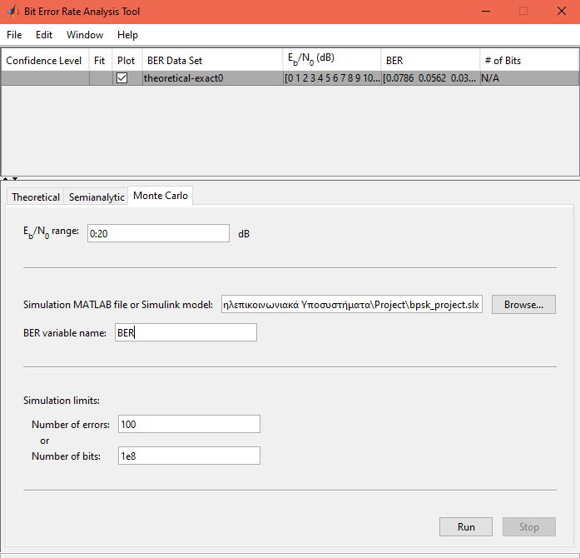Then, in the bertool, weswitch tabs to Monte Carlo, where we change as follows:

Setting range to 0 up to 20, set the location of my file, in BER variable name set the SAME name as the one in workspace and, finaly, in simulation limits set the SAME values as the ones in Error Rate Calculation.

In the end, press Run to run the simulation. The Constellation Diagram appears and afterwards, on the curve of the theoretical BER appears also the simulated with the parameters I set.

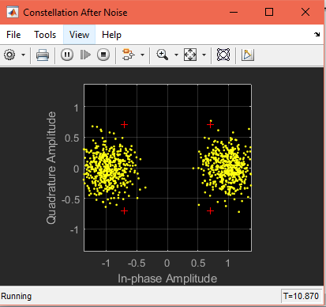

Following is the simulated BER.

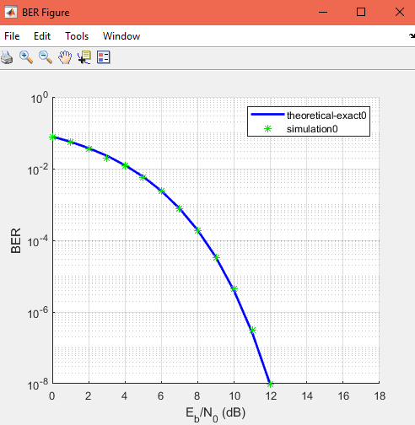

Conclusions:

Setting various values for the SNR we can see that we got the result that we expected, as the theoretical and the simulated BER are in line. By running the simulation, we also note that the Constellation Diagram is becoming more clear as the values of the SNR increase.

References:

<http://www.dsplog.com/2007/08/05/bit-error-probability-for-bpsk-modulation/>

<http://ecelabs.njit.edu/ece489v2/Lab3.php>

<https://www.youtube.com/watch?v=F6M43EIpbv8&t=146s>

<https://www.ijser.in/archives/v1i2/MDExMzEwMTA=.pdf>

<http://article.ajnetcom.org/html/10.11648.j.ajnc.20160505.11.html>

<https://www.researchgate.net/figure/Example-of-BPSK-modulation-format-a-binary-signal-and-b-BPSK-modulated-signal_fig2_221907745>